Chapter 3, Problem 42

Using Fig. 3.88, design a problem to help students better understand mesh analysis using matrices.
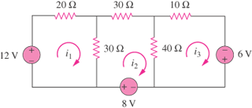
V₁
V₂
V₃

Figure 3.88
For Prob. 3.42.

